
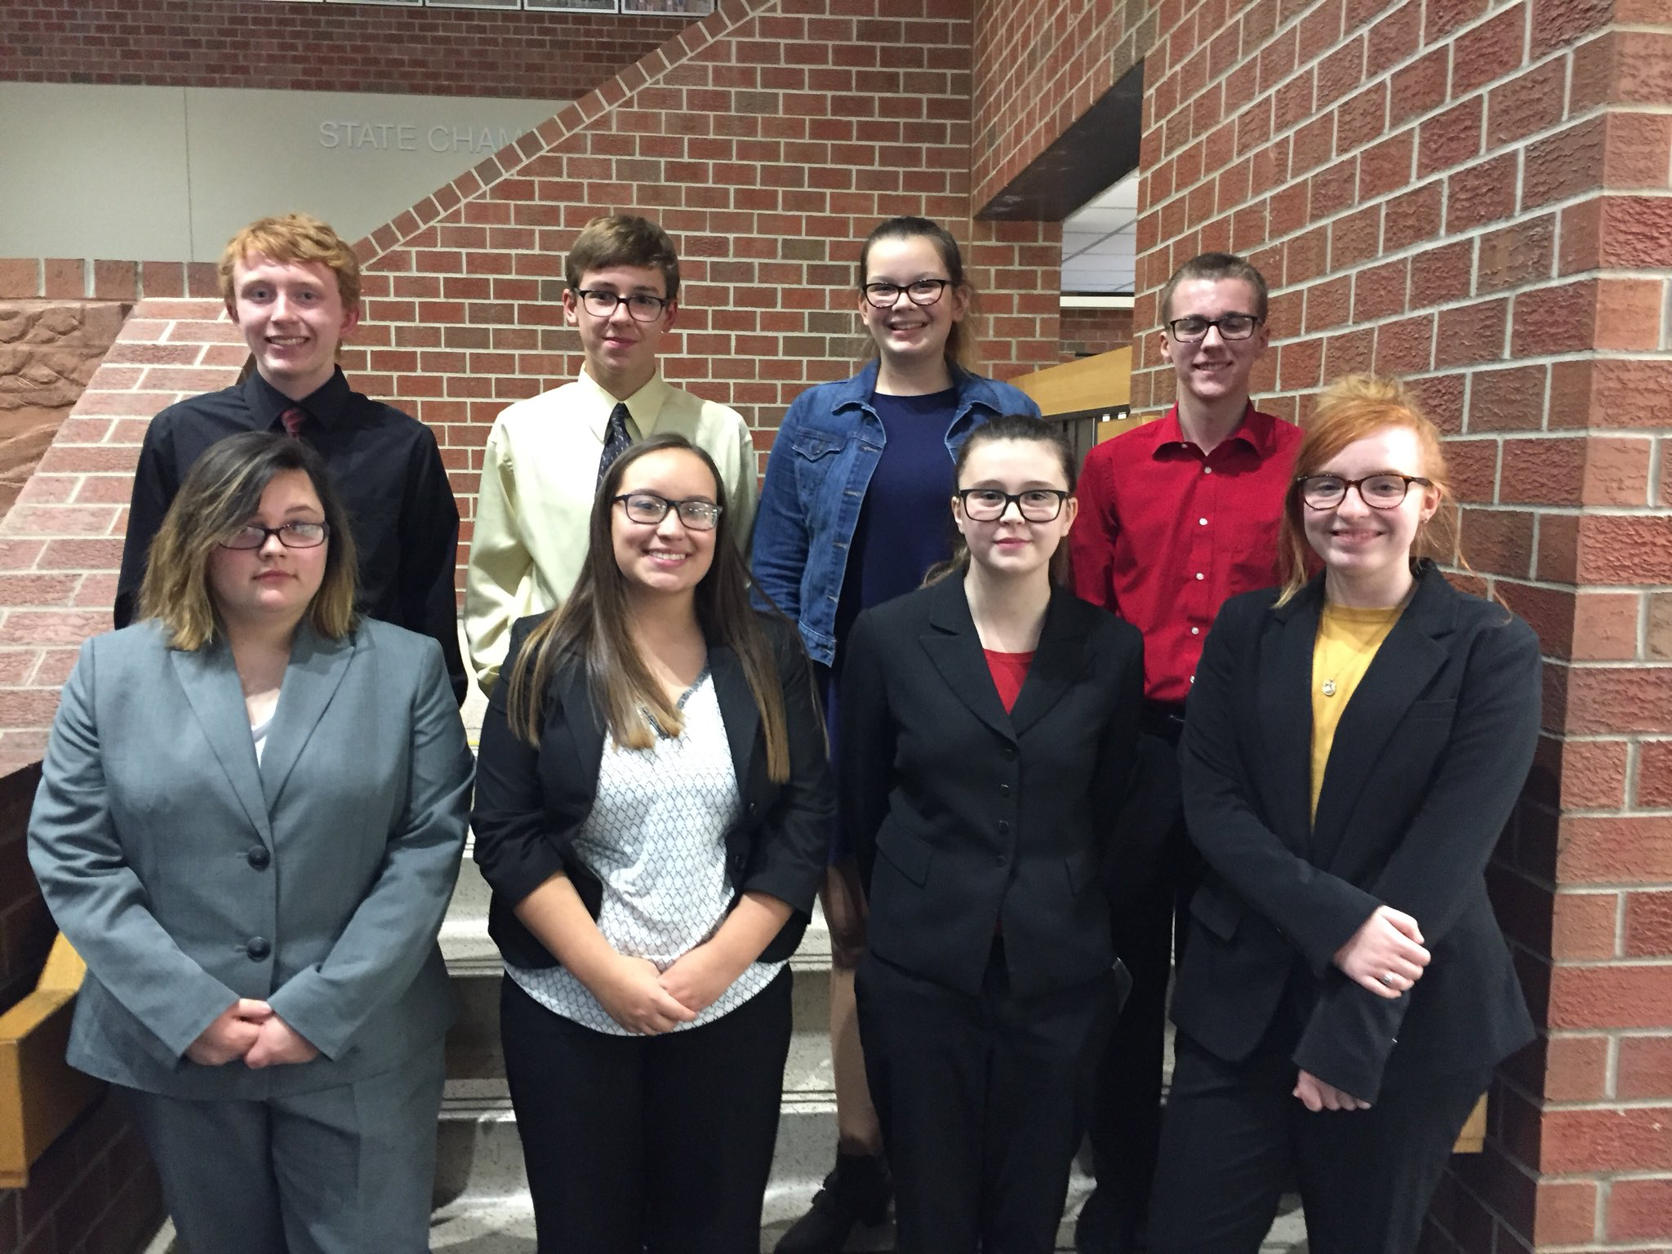
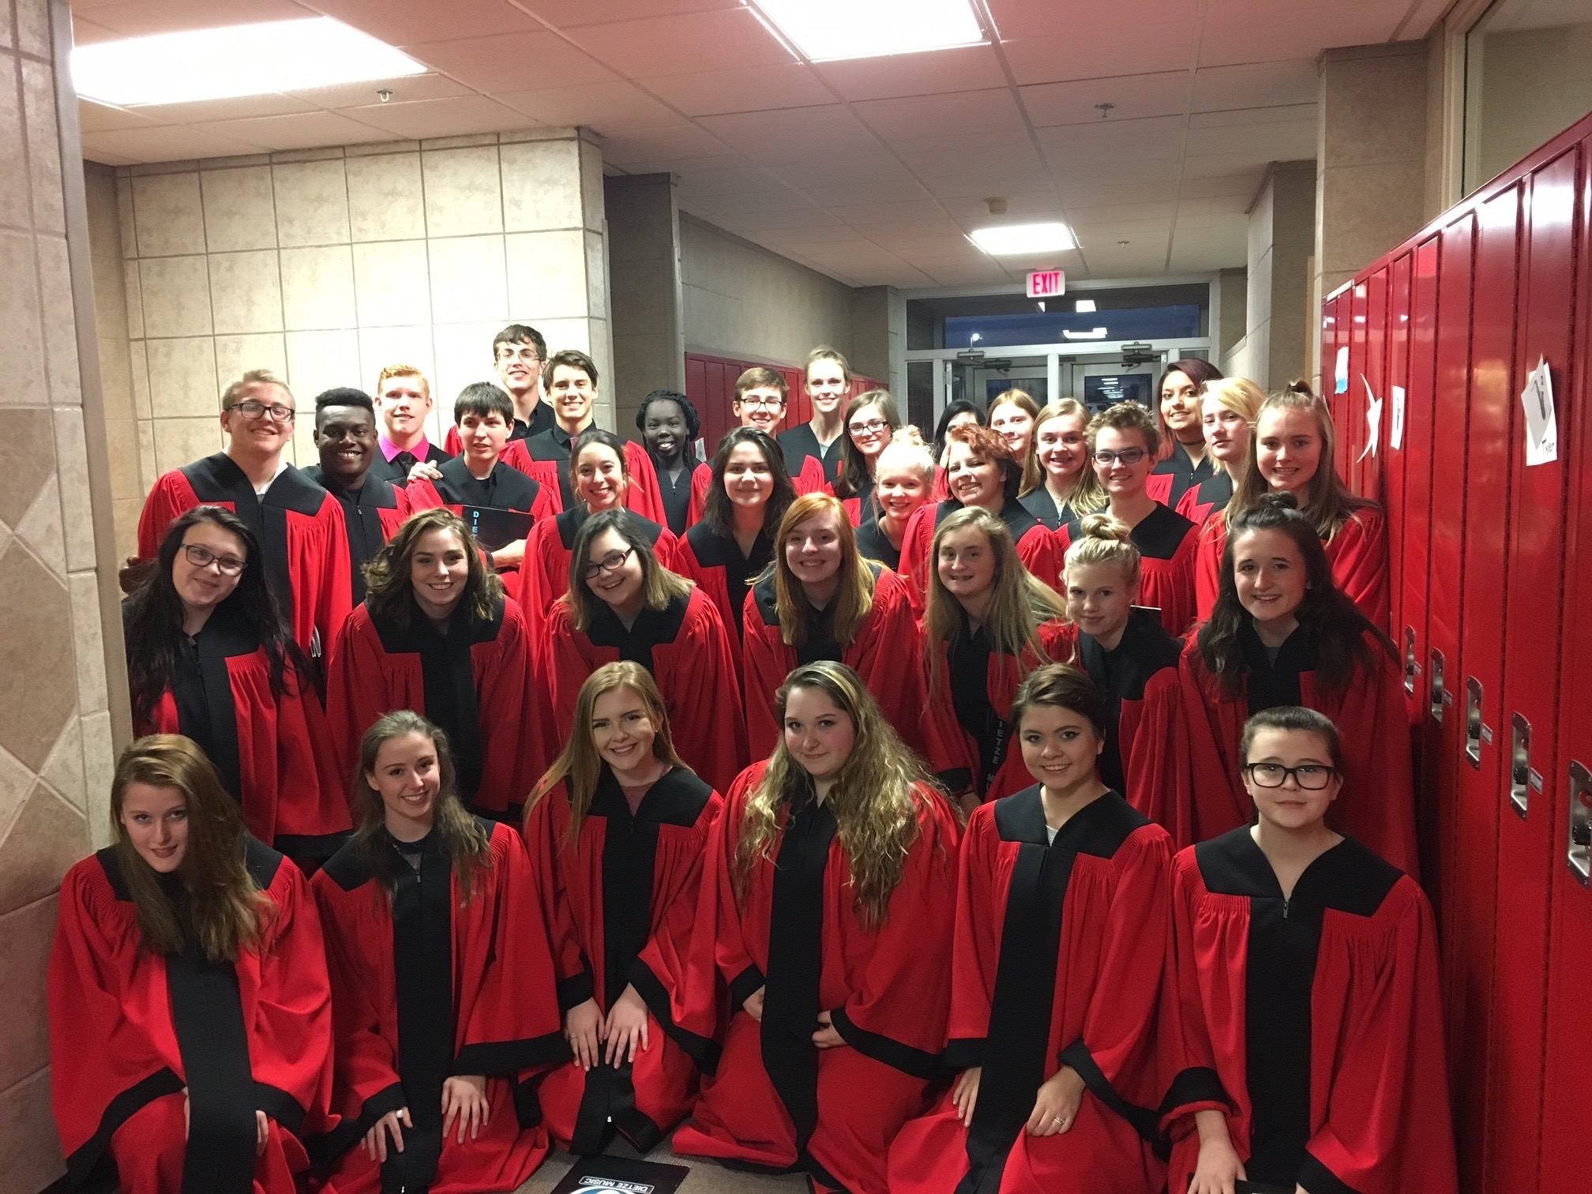
Douglas County West Choir attended
the NCC Choral Festival on November
6th hosted by Platteview High School.
The DC West Choir had the opportunity
to work one-on-one with clinician, Mr.
Doran Johnson (Vocal Music Director at
Westside High School in Omaha). Mr.
Johnson praised the choir for their
sound and the effort the students put
in to their performance. Later in the
day, all the choral students from the
conference participated in mass choir
rehearsals led by Mr. Johnson. The
students enjoyed working with Mr.
Johnson! The day was long, but DC
West represented the district well
throughout the whole day. The evening
culminated with a 6pm concert in
which each school choir performed
individually and as a large group. I’m so
proud of our choir, I appreciate their
hard work and commitment to
excellence!
We have twenty participants this year, and our
team captains are Noah Boger and Dylan Hansen. Almost
everyone that finished the season last year came back and
we currently have 10 varsity members. We also have a large
group of Novice members that competed at their first
novice tournament on Friday, Nov. 3rd where our Duo
placed 4th.
Our team goals for 2017-2018 are to bring a full team
to Districts (2 entries in each event), to win or get runner
up at our NCC competition, and qualify seven students to
State.

Speech Coach – Gayle Smith
Lorem Ipsum Dolor
Dolor Sit Amet

Follow us on Twitter: #dcwestfalcons

November Board Report

Troy Glock,

Activities Director

Caden Scott and Ryan McArdle – State Cross Country Qualifiers
Final Records: Football 4-5, Softball 15-16, Volleyball 22-10

Choir Director, Dawn Beyl

